Extra 14-1 Create a Product Receipt application

In this exercise, you’ll create a simple application that uses a GridView control to let the user update the on-hand quantity for products when a shipment is received.

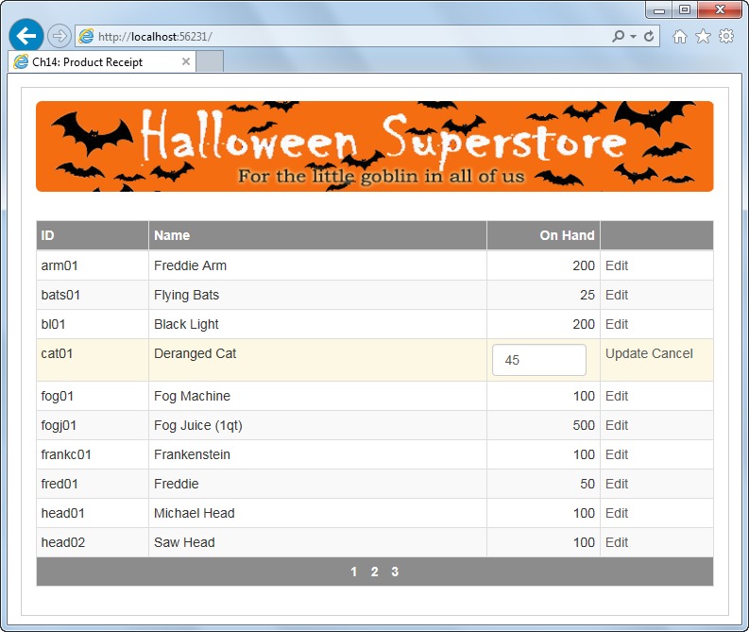

Update the GridView control so it allows for editing

1. Open the XEx14ProductReceipt application in your exercises_extra directory. This application contains a page with a starting GridView control and its data source, a validation summary control that will be used to display error messages for validation controls you’ll add later in this exercise, and a label that will be used to display database errors.
2. Set the ReadOnly property of the Name field to True so this field can’t be changed.
3. Add a command field to the GridView control that provides for updating a row.
4. Add an event handler for the RowUpdated event of the GridView control. Add code that checks for database exceptions and displays error messages in the label near the bottom of the page. Don’t check for concurrency errors, though, since the data source doesn’t provide for concurrency checking.
5. Run the application, and increase the on-hand quantity for one of the products. If this works, try updating the product again by clearing the on-hand quantity. This time, an error message should be displayed indicating that a database error occurred.

Convert a bound field to a template field and add validators

For the following steps, you can work in either Source View or Design View.

1. Convert the OnHand field to a template field. Then, in the EditItem template for this field, give the text box an appropriate name and assign the form-control class to it.
2. Add required field and compare validators after the text box, and assign the text-danger class to the validators. The compare validator should check that an integer greater than or equal to zero is entered. If an error occurs, display an asterisk following the text box, and display an error message in the validation summary control at the bottom of the page.
3. Run the application, and test that the validators you just added work the way they should. Note, however, that the asterisks display below the text box.

Make some formatting adjustments with Bootstrap

For the following steps, it’s easiest to work in Source View.

1. In the EditItem template, add a div element and assign the col-xs-11 class to it.
2. Move the textbox within the div element.
3. Run the application and test it to make sure that the asterisks now appear next to the text box rather than below it.
4. Notice that the Bootstrap column CSS class has added padding to the right and the left of the div element. If you don’t like this, you can use a custom CSS class to adjust the padding of the div.